Tutorial 6

Module Name: Shopping Workflow – Manual Test Execution
Test Case ID: TC06
Tester Name: Vora Riya

Scenarios:
- Scenario ID: 6a
Scenario
Verify DemoBlaze website opens successfully
Test Steps
1. Open Chrome.
2. Enter DemoBlaze URL.
3. Wait for page to load.
4. Observe the homepage.

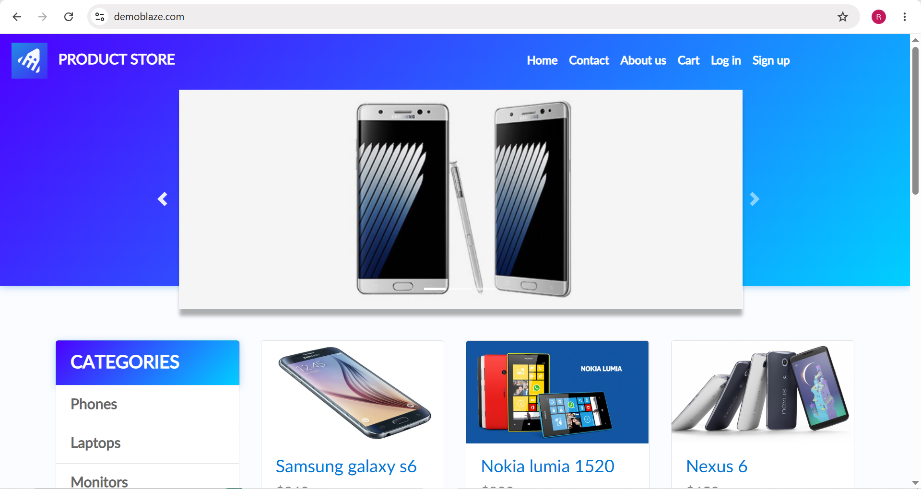

- Scenario ID: 6b
Scenario
Verify products are displayed on homepage
Test Steps
1. Open homepage.
2. Scroll to product section.
3. Observe available products.

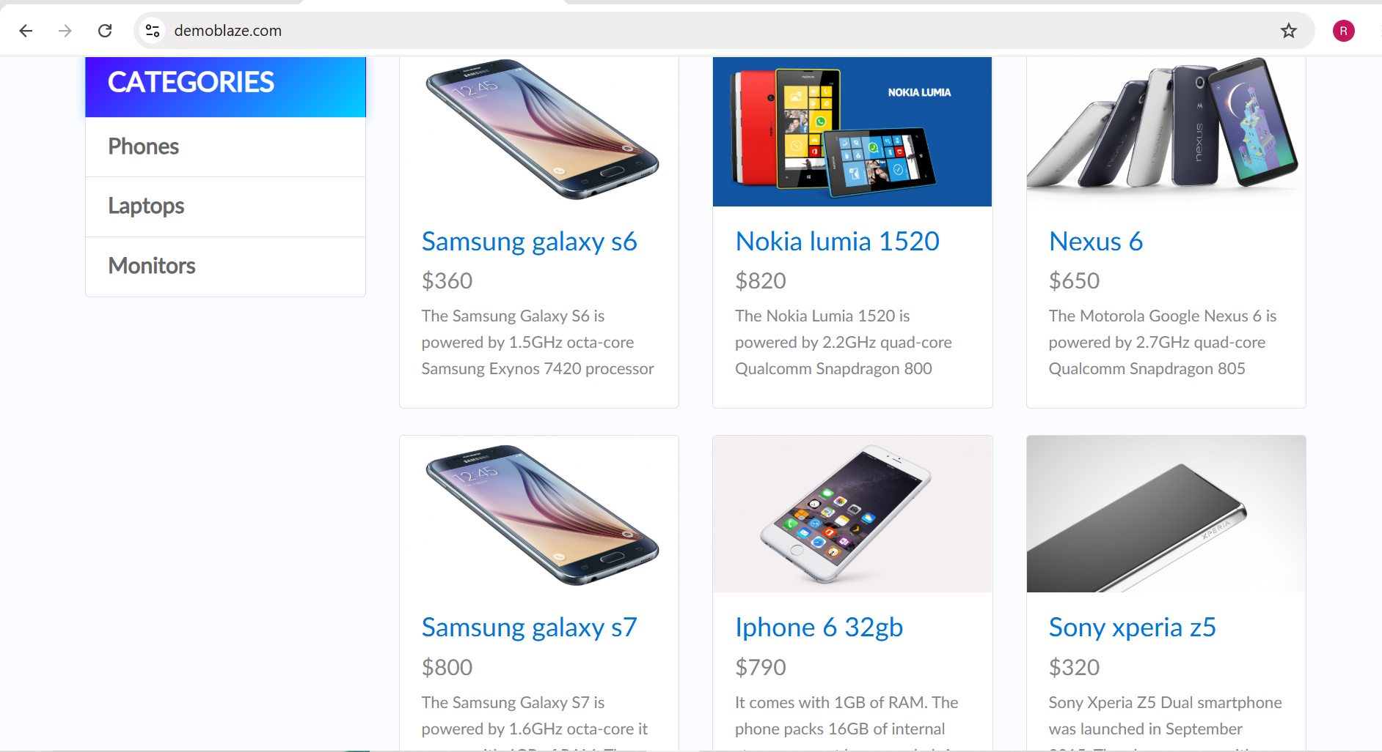

- Scenario ID: 6c
Scenario
Verify product can be selected
Test Steps
1. Open homepage.
2. Locate Samsung galaxy s6.
3. Click the product.
4. Observe the result

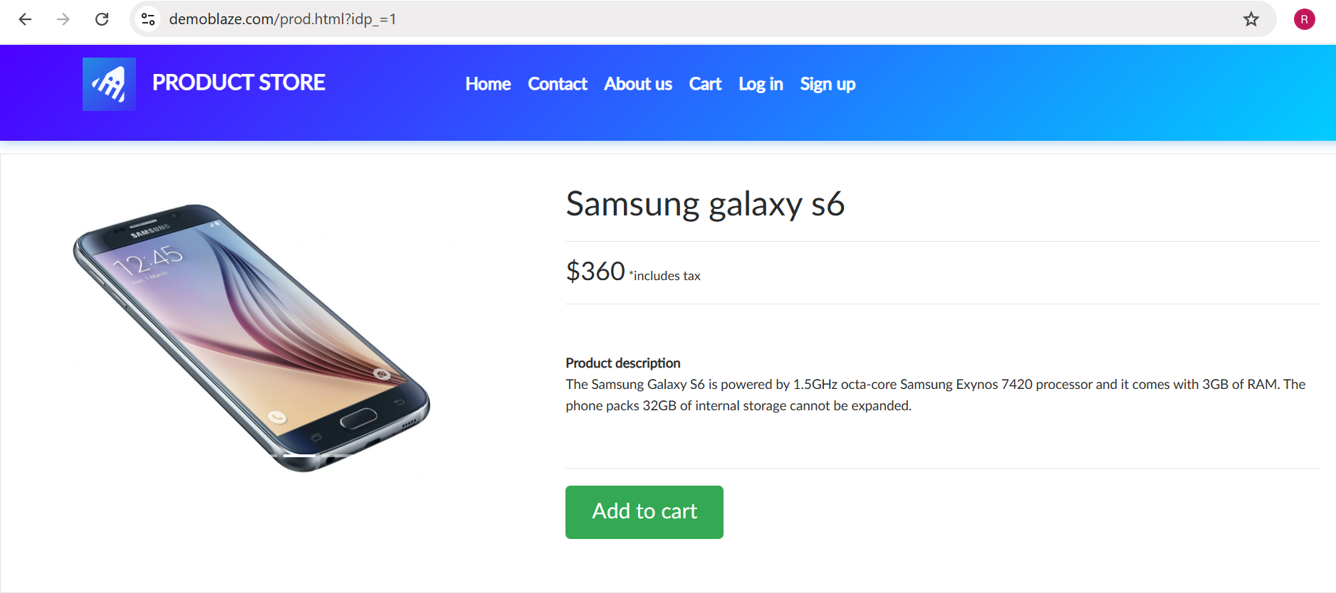

- Scenario ID: 6d
Scenario
Verify product details are displayed
Test Steps
1. Select Samsung galaxy s6.
2. Check product name.
3. Check price.
4. Check description and Add to cart button.

- Scenario ID: 6e
Scenario
Verify Add to Cart functionality
Test Steps
1. Open product page.
2. Click Add to cart.
3. Observe confirmation.

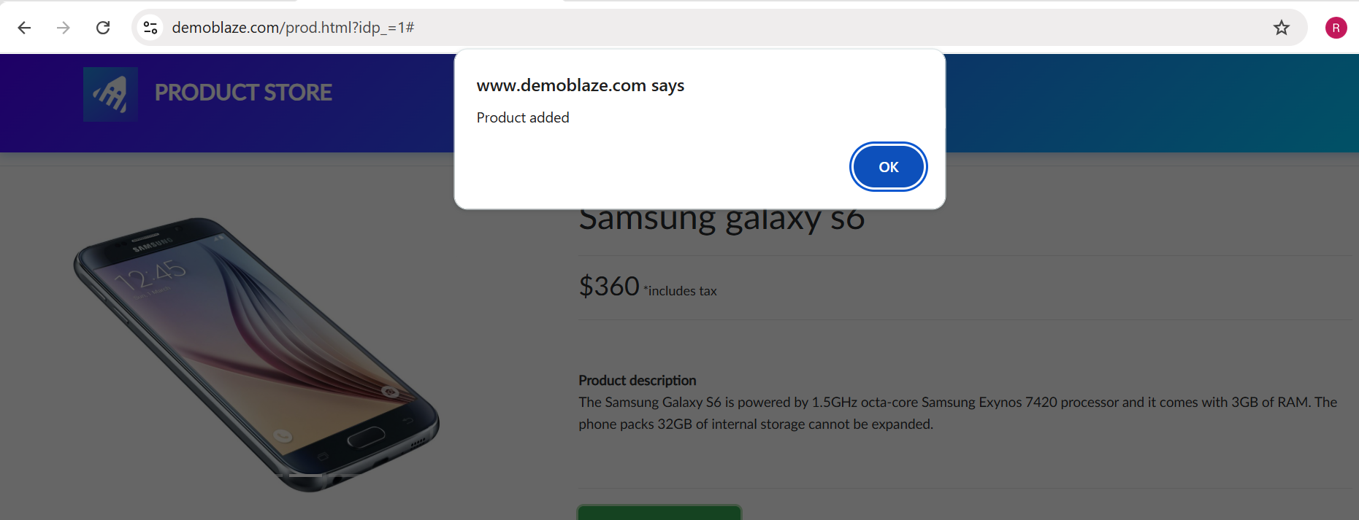

- Scenario ID: 6f
Scenario
Verify Cart page opens successfully
Test Steps
1. Add product to cart.
2. Click Cart.
3. Observe Cart page.
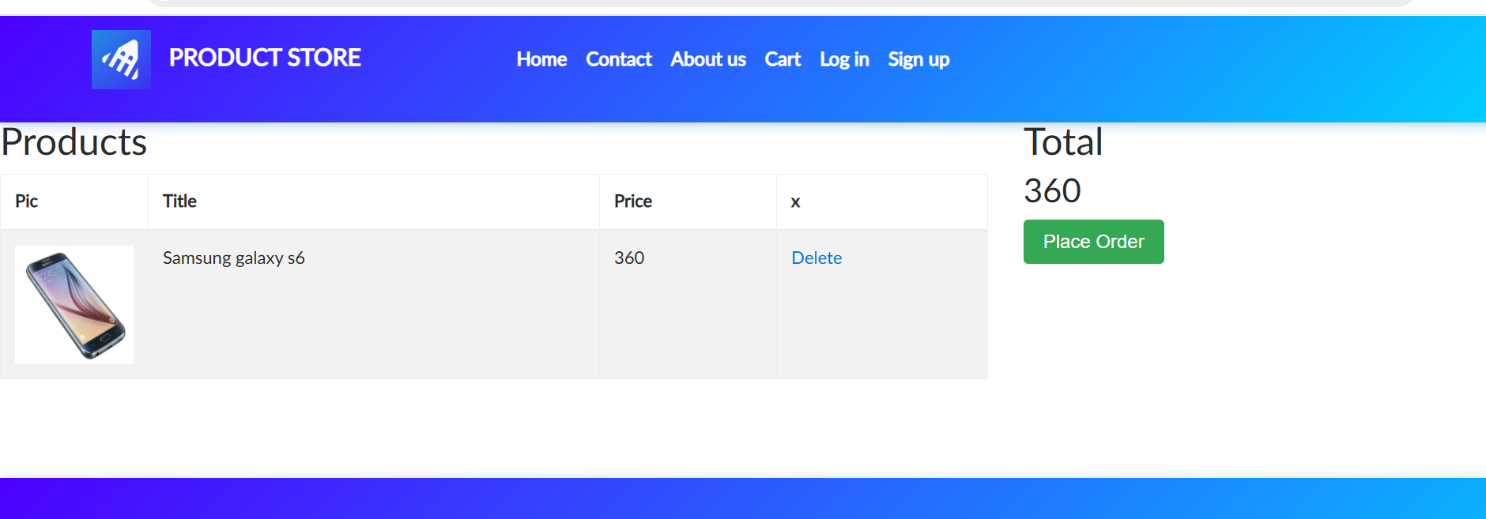

- Scenario ID: 6g
Scenario
Verify product details in Cart
Test Steps
1. Open Cart.
2. Verify product title.
3. Verify price.
4. Verify total.

- Scenario ID: 6h
Scenario
Verify Place Order form opens
Test Steps
1. Open Cart.
2. Click Place Order.
3. Observe order form.

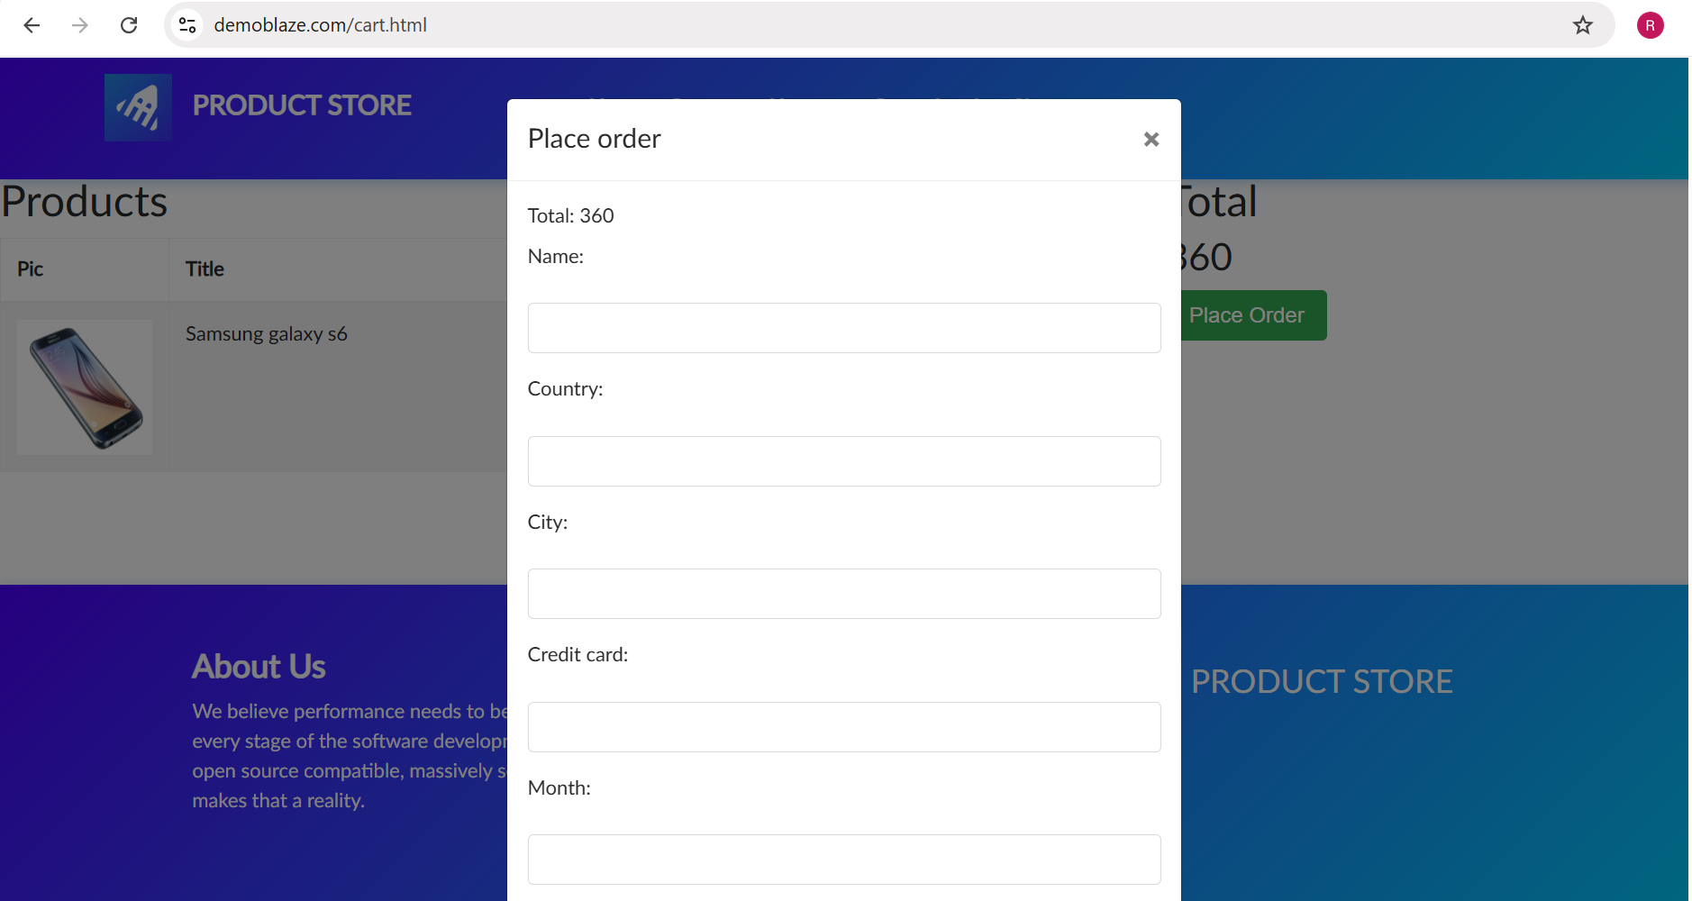

- Scenario ID: 6i
Scenario
Verify customer details can be entered
Test Steps
1. Open Place Order form.
2. Enter valid customer information.
3. Verify entered values.

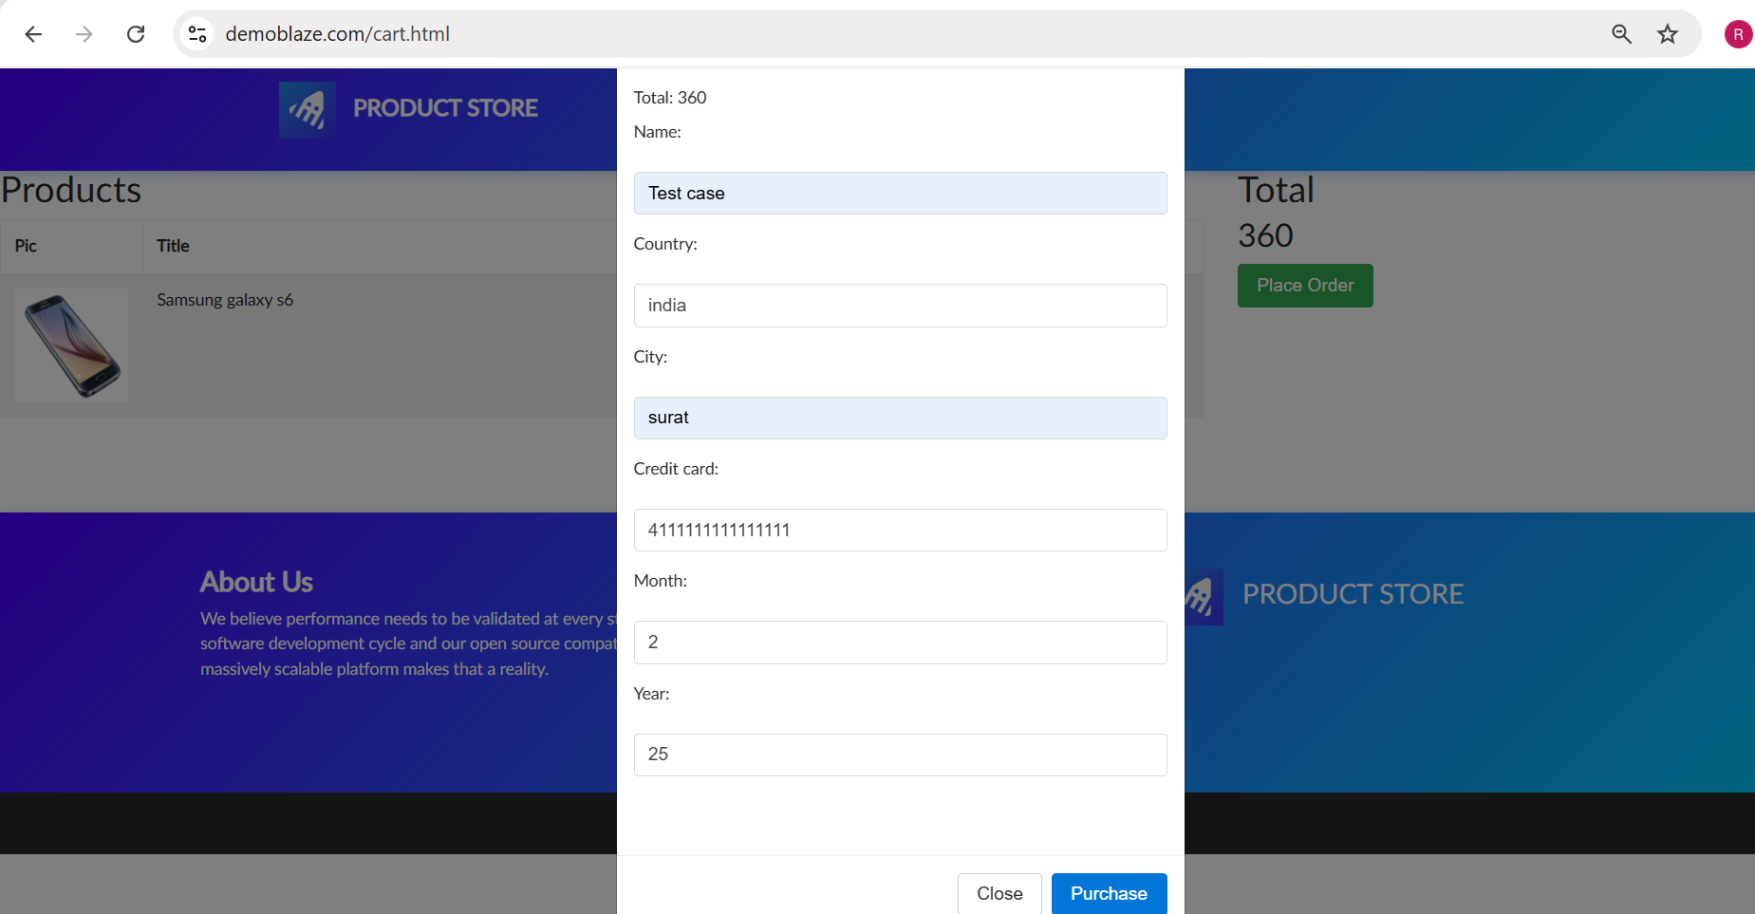

- Scenario ID: 6j
Scenario
Verify successful order submission
Test Steps
1. Enter valid customer details.
2. Click Purchase.
3. Observe confirmation.

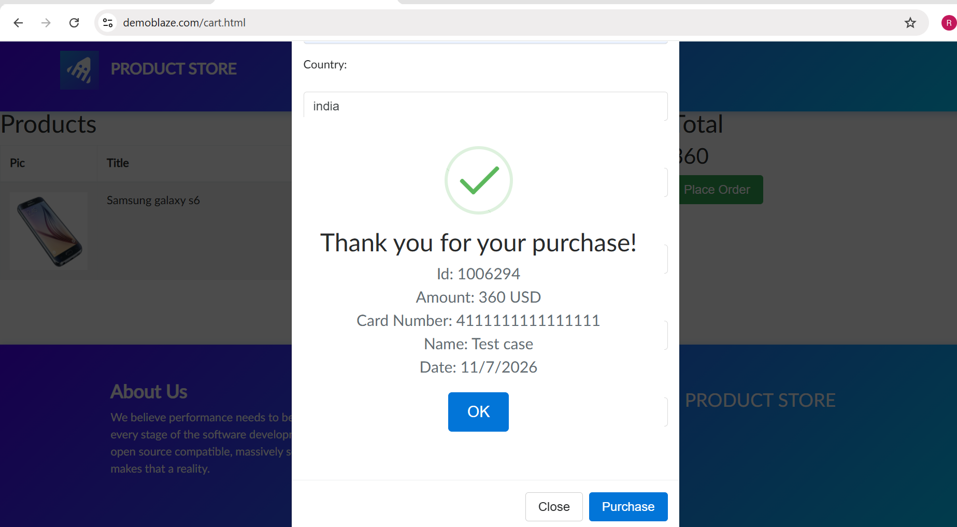

Test Result Summary

Total Test Case | Pass | Fail | Blocked | Pass%
10 | 10 | 0 | 0 | 100%

